Setting up Google Jupyter Notebook (aka Colab) programming environment:

Objectives

* Enhance your understanding on Python Jupyter Notebook programming environment
* Set up Google Jupyter Notebook (aka Colab) programming environment
* Connect Colab with your Google Drive, and read/write files from/to Google Drive
* Be about to upload and download Jupyter Notebook files to and from Google Drive

Prerequisite: you can use your personal Google account or set up another one for this exercise

1. Log into your Google account
2. Open your Google drive (GDrive) via <https://drive.google.com/>
3. Create a folder for your class. For example, IT166 or IT 170.

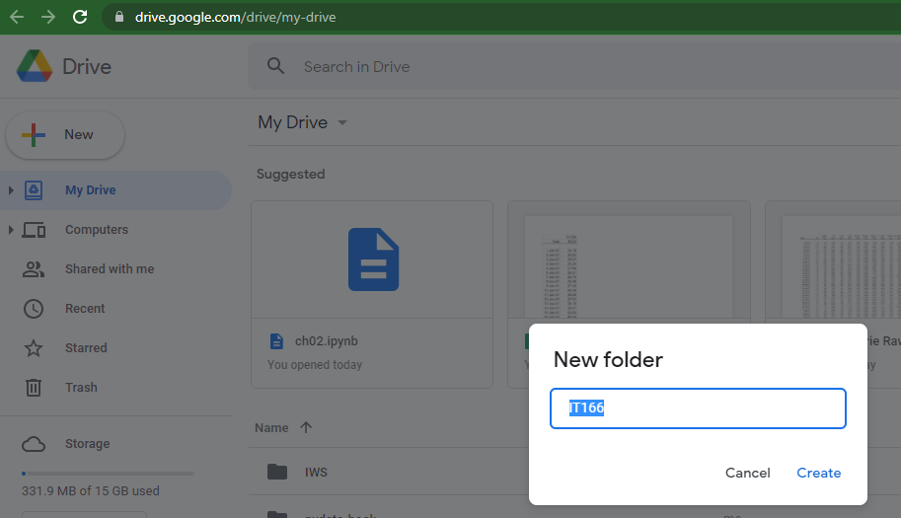

1. Upload the two provided files (first.jpynb and username.csv) to “IT166” folder on your GDrive. (note: you should download the two files from Reggienet to your local computer; and then drag and drop them to your GDrive)

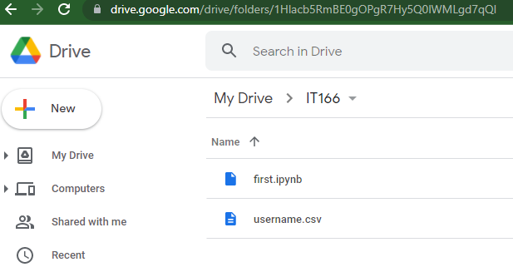

1. Right click first.jpynb and choose “Open with”. If this is **not** your first time to run Colab application, you should use the option “Google Colaboratory”. Otherwise, you should select “Connect more apps” and a window will pop up. Please type in “Colaboratory” in the search field, and press “Enter”.

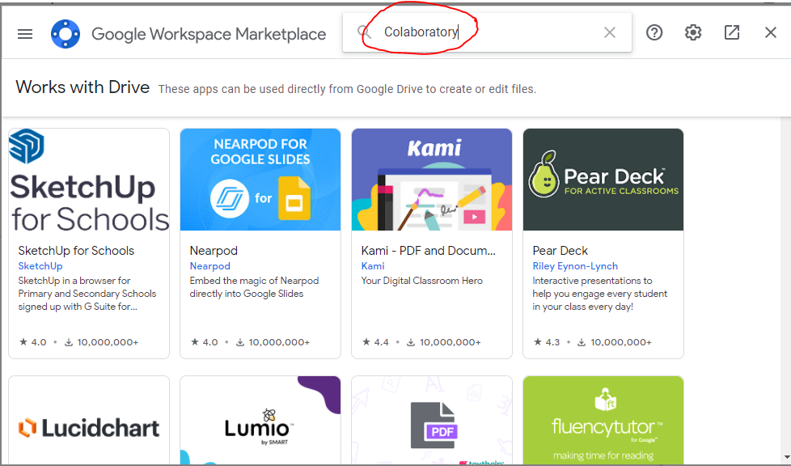

You should find the icon as below and install the Colab app. (Note: since I have installed this app, you can see the “Installed” label on top of the icon below)

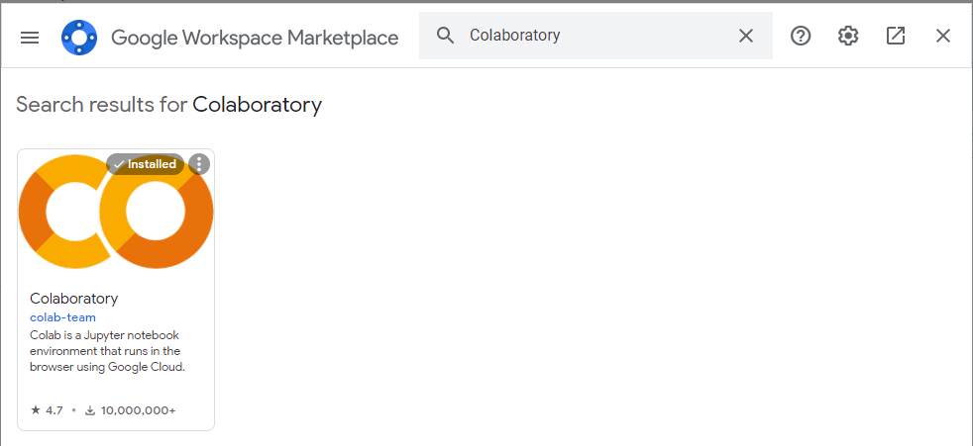

1. Once this Jupyter Notebook is running, you should see
2. When you run the code to mount GDrive, you will see a pop-up window below and choose “Connect to Google Drive”; and then select your Google account, and “allow” the access.

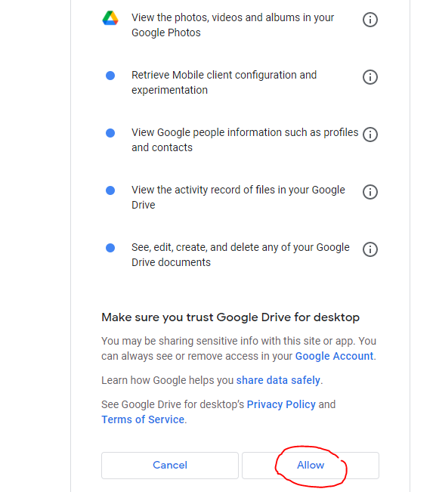

1. Run the code step by step by clicking 

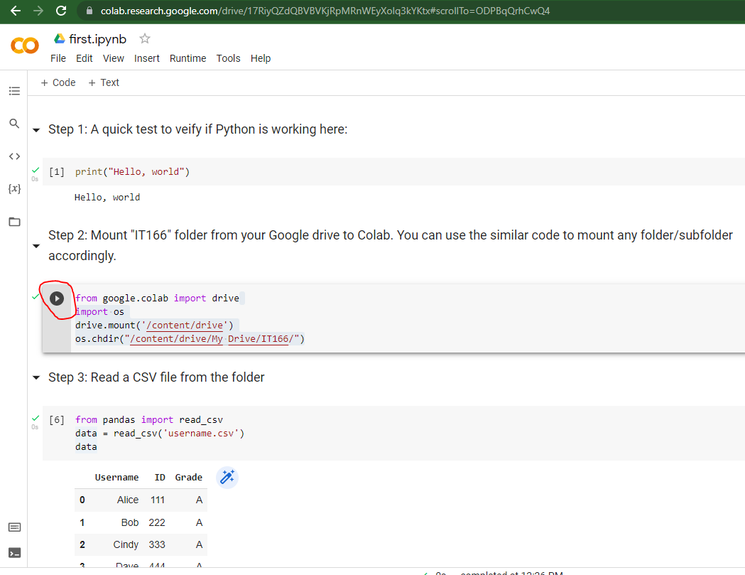

1. If you can see the output as below, you have successfully set up the Colab programming environment.

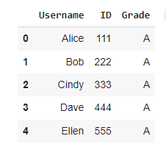

1. To download the Jupyter Notebook file (first.jpynb), simply right click the file name and choose “Download”.